# How to: Visual Crossing Basics

MicroStrategy has a variety of ways to create tables and data visualizations including mapping of geographic data. Visual Crossing is the add in to MicroStrategy that PEPFAR uses primarily to map geographic data in PEPFAR Panorama. This document will walk you through how to create a map of MER indicators using polygon data (OU, PSNU, etc) and then how to map facility point data.

## Thematic Mapping at the PSNU Level

When building Panorama Dossiers, you may find that you are interested in seeing how MER indicators are distributed throughout a country for purposes of identifying geographic patterns. For example, are all poor performing PSNUs in the same region of the country? Or are they more randomly dispersed? Could there be a geographic or physical reason why certain PSNUs are lagging behind others? These questions could potentially be answered by looking at a map.

To make this map readily available in a Pano dossier, you’ll need to build it out in Visual Crossing – a mapping add-on for MicroStrategy.

### Creating your tables

Similar to how you would create other graphics in MicroStrategy, the mapping process starts with the creation of a table displaying geographic level that we want to map, the unique IDs that identify each geographic areas as well as the indicators we would like to visualize.

When you create a new page in your dossier, you will see a placeholder for a Grid visualization. As well as an editor panel for that visualization.

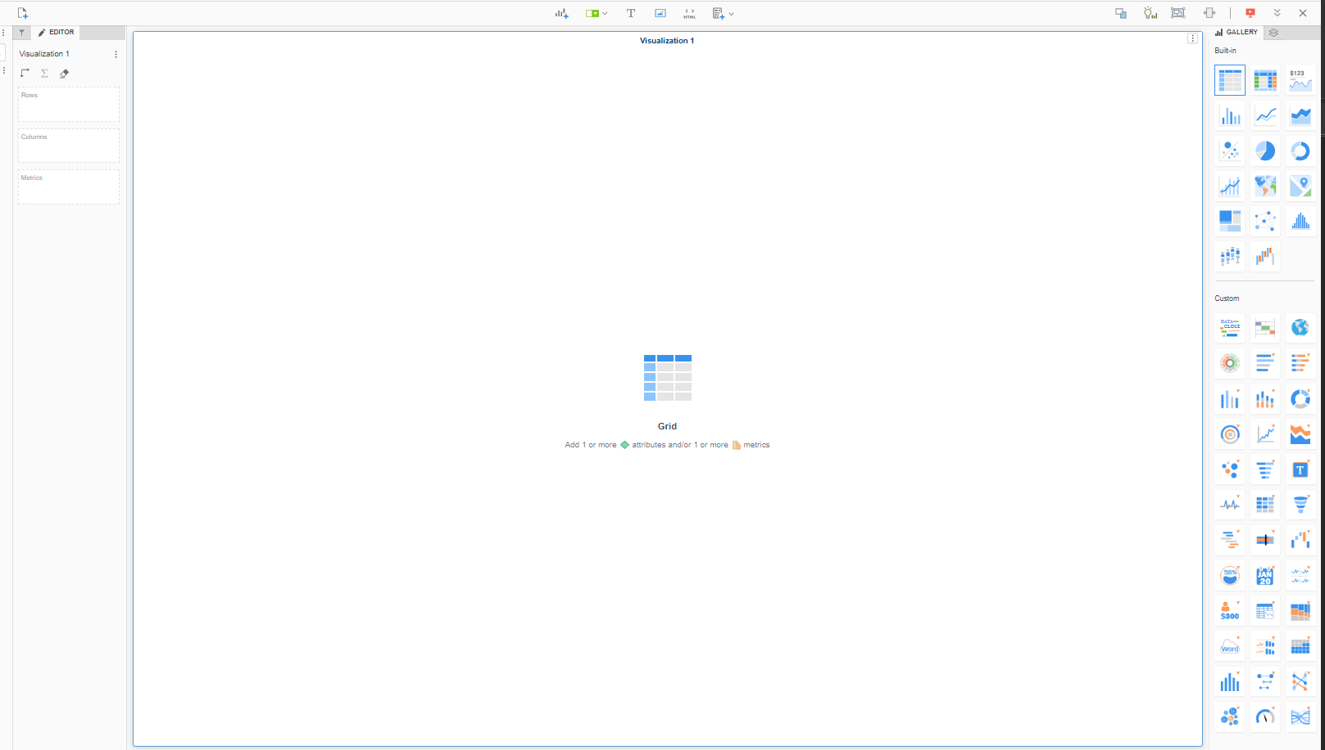

If you don’t see the editor panel, it can be opened by clicking the pencil in the panel to the far left of the screen (A).

A

B

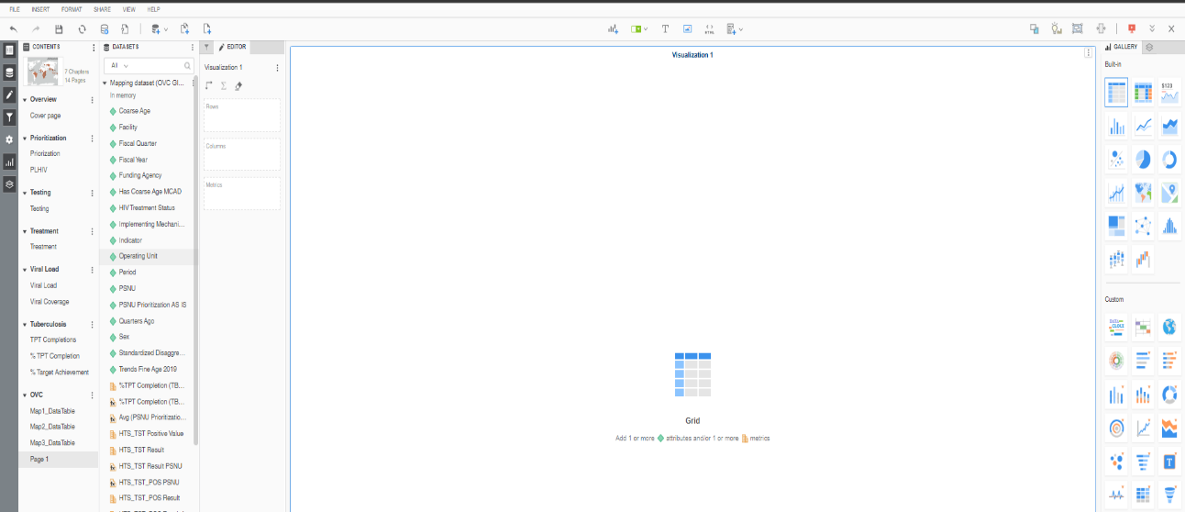  
In the editor panel is where we are going to place indicators to build the different dimensions of our table. These indicators can be found in the dataset panel. If you do not see the dataset panel, make sure the dataset button is selected on the far-left side of your screen (B).

For a map of PSNUs we will first want to click and drag the PSNU metric from the dataset panel into the “Rows” box of the editor panel. Once you do this, a list of PSNU’s will appear in the visualization area.

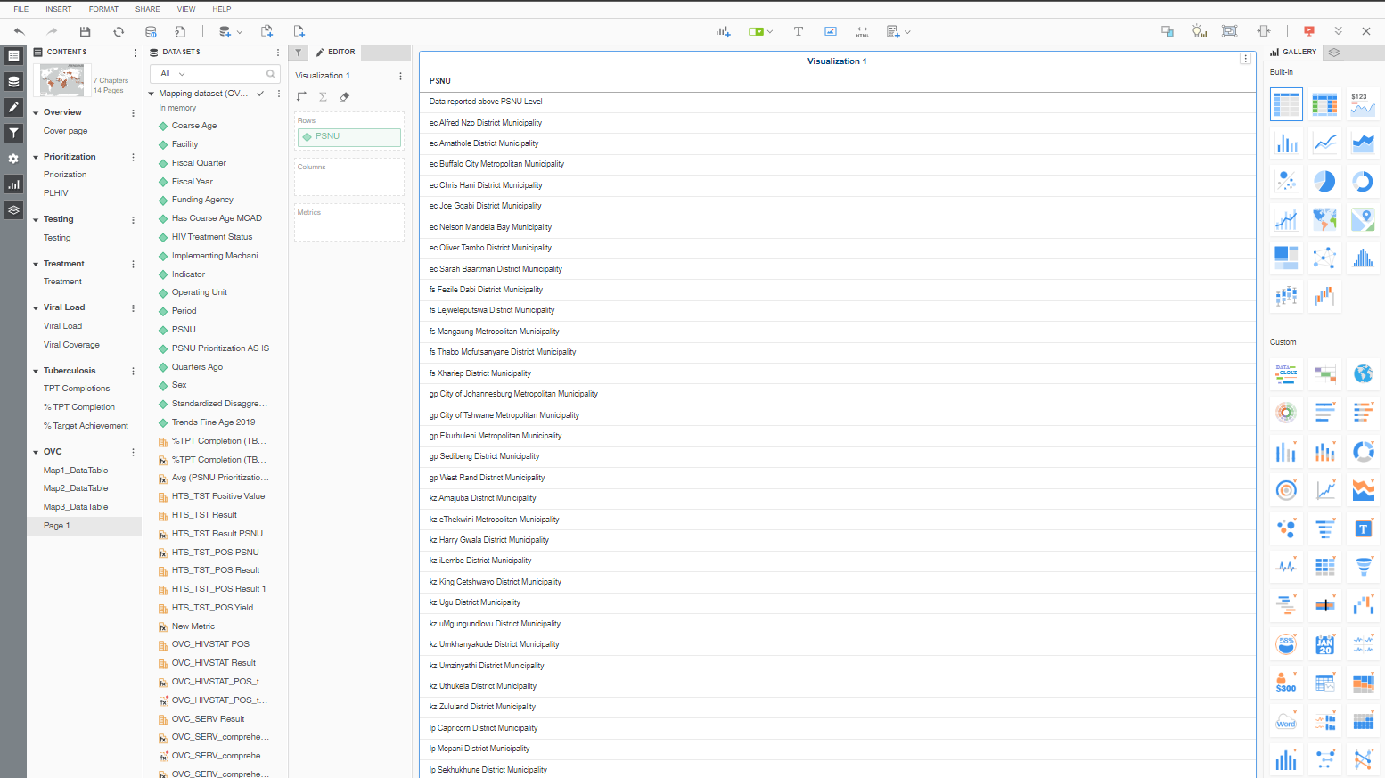

Next, we will want to add the metric that we are interested in mapping to the “Metrics” box. For this demo, I will use HTS_TST Result. If the metric you are interested in mapping is not available in the dataset panel, you may need to reach out to someone from the data systems team to add it for you. Or, as in the case of calculated indicators, you may need to create a new metric. We will not cover that process here.

Once you add the indicator to the “Metrics” box, the data should appear as a new column in your table. Note that the numbers as they appear in the table may need to be filtered further in order to be fully accurate. For example, may need to filter for a particular fiscal year and standardized disaggregate. Once again, we will not cover how to do that in this document, but more resources can be found on the MicroStrategy PVA.

Finally, we will need to add our unique ids (uids) to our table. To do this right click on the PSNU attribute located in the “Rows” box within the Editor panel. Select “Display Attribute Forms” and then check the box next to “ID” and click “OK”.

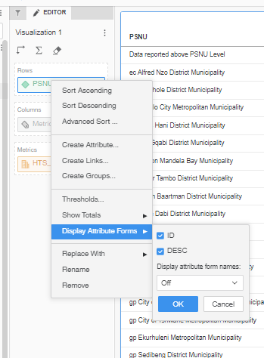

You should now see a new row in your column with alpha numeric IDs. These are unique IDs that correspond to each unique geographic attribute that is stored in panorama (PSNU boundaries, facilities points, etc). This column is needed for us to join the table that we’ve created to geographic data for mapping.

### Setting up your map

Now that our table is ready, it is time to create our map! In the Gallery panel, you should see a variety of different visualization types. If you do not see the Gallery panel, you can open it by selecting the bar graph icon on the far-left hand side of your screen.



The Gallery panel has two sections – “Built In” and “Custom”. In the Custom section, you should see a globe icon. To add our map to the page, make sure that the table we just created is selected and then click this globe icon.

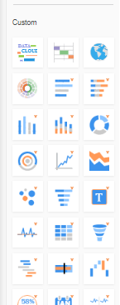

Once selected, you should see a map appear in place of your table and a pop-up window that reads “Create Layers for MicroStrategy Dataset”.

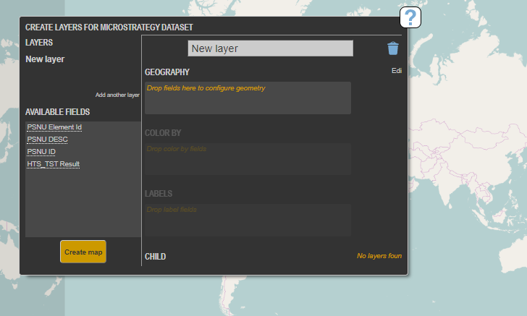

This window is what is going to allow us to select the geography and indicators that we are looking to map.

To get started we will need to join the table we previously created to a geographic dataset. We do this by first dragging out uid column (PSNU ID) to the “Geography” box – Note that we do not want the “PSNU Element ID”.

After you drag the “PSNU ID” field to the “Geography” box, a message appears below the box that reads “Please add more fields or configure manually”. Select “configure manually”.

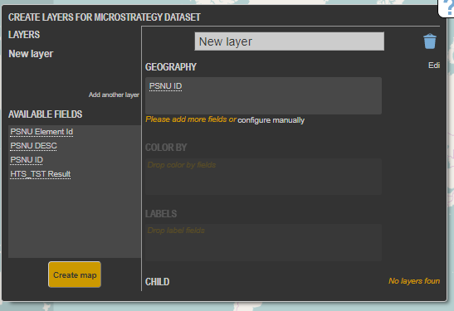

This opens a new pop-up box with various geometry options. Select “Configure Manually” again.

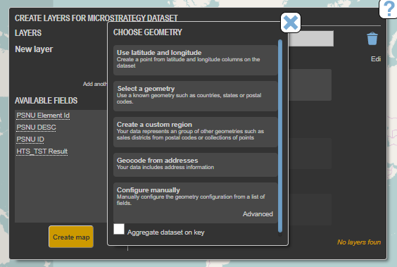

And then select “Advanced”.

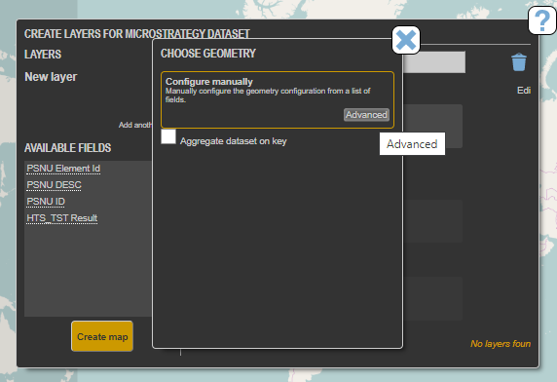

Clicking “Advanced” will open another popup window with a dropdown menu. From that dropdown menu, select “Join”.

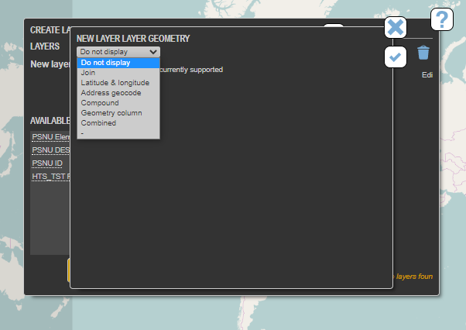

Clicking Join causes some new options to appear including the option to change the geometry. Under where it says Geometry there will be a long sting of letters and numbers followed by a button that says “Change”. Click “Change”.

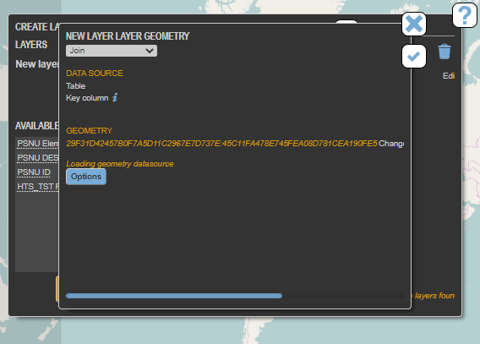

Another window will pop up with a list of geometry options. Scroll to the bottom of the list and select “VcPepfarPolygons”. The popup window will disappear. In the remaining window, you will see a new table titled “Data to Geometry Join”. Under the “Data” column, you should see “PSNU ID” and under the “Geometry Source” column, you should see “uid”. You will also see a “Match quality” listed beneith the table. This gives you an idea of the percentage of features the program was able to match to your table.

There are a variety of reasons for why this percentage may not be 100%. However, if the match quality is listed as 0%, then something was selected inproperly. Go back and check your selections.

Next, click the check mark in the top righthand corner of the window to close the window.

Then click the X in the top right corner fo the “Choose Geometry” window to close.

In the remaining window, we can now set the color and label parameters for our map. To do this, move the indicator you would like to map from the “Available Fields” box on the left over to the “Color by” box. If you would like to add labels to your map – values that will pop up when you hover your mouse over a PSNU, then you can add these to the “Labels” box.

For example, I would like to have the colors on my map show “HTS_TST Result”, so I moved that indicator to the “Color by” box. I would also like to show the name of the PSNU and the HTS_TST value when I hover over a PSNU so I moved the “PSNU DESC” field as well as the “HTS_TST Result” to the “Labels” box.

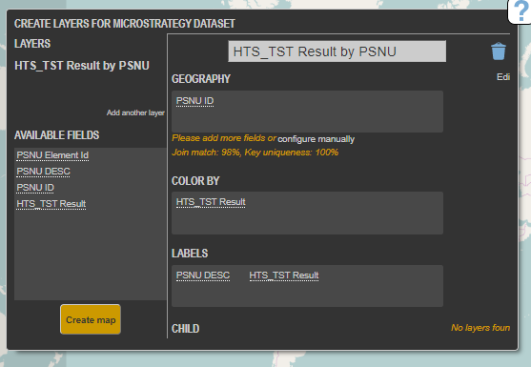

It is also recommended that you give your layer a descriptive name. For example “HTS_TST Result by PSNU”.

Once you’ve done this, you can click “Create map” and your map should appear in the visualization pane.

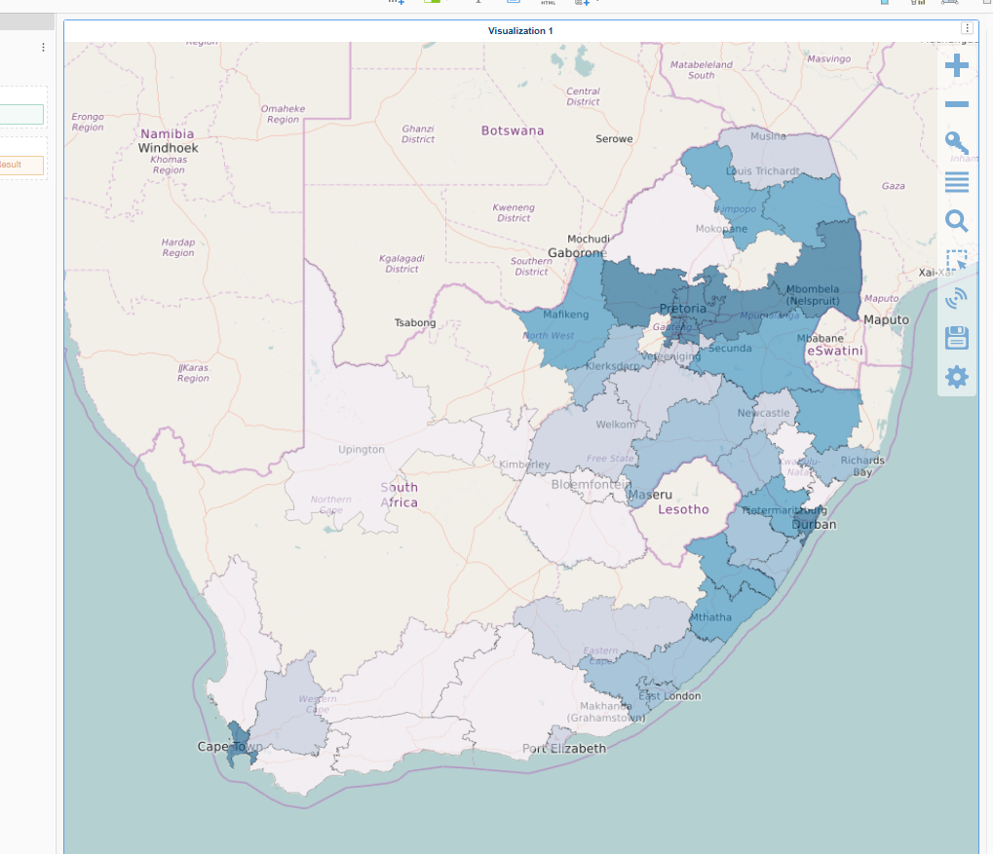

### Styling your map

Once you’ve created your map, you may want to change how it is displayed. For example, you may want to change the color ramp. To do this, click on the hamburger menu displayed along the right side of your map panel. It lookes like four parallel horizontal lines. This will open a pop up window with a list of all layers from your map. Usually, this will be the base layer (“OSM Layer”) which includes the oceans, land, lakes, roads, etc that provide context for your map as well as the layers you have created (ex: “HTS_TST Result by PSNU).

From this window, you can toggle the different layers on and off, reorder your layers and much more. For now, we will focus on changing the styles assigned to the layer that we previously created.

To do this click on the name of your layer. This will open up some options for styling.

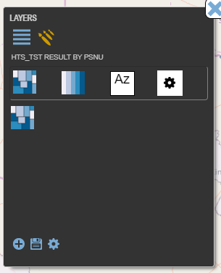You can play around with the four different sections displayed here, but to change the color ramp we are going to click on the second icon that shows the color ramp made of parallel vertical bars.

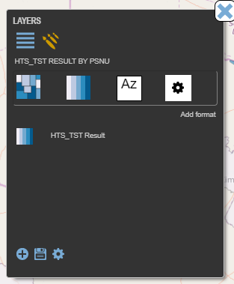

Then click the layer name.

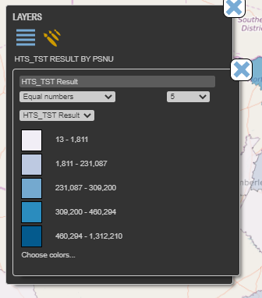 This opens a window where you can change the number of categories shown on your map (A). The method used to create the different data bins (B). The metric you are displaying – if you have more than one in your table (C). As well as the color ramp used (D).

A

B

By clicking on the individual colors and number values, you can edit these options manually, but this is not recommended as a different bin calculation will need to be made for each OU. Therefore, it’s best to allow MicroStrategy to calculate these values for you.

C

When choosing your color scheme, keep in mind that it is best practice to use a sequential color scheme (like the one shown to the left) when working with a data scale that does not have a meaningful point of center. Ex: When mapping the number of people tested for HIV in South Africa, the scale here goes from 13 (the minimum) to 1,312,210 (the maximum) and the color helps show us where each PSNU lies on that continuum.

D

However, if we were looking at the percent change in HTS_TST between two quarters for example, it would be appropriate to use a diverging scale – for example, one that goes from red to white to blue. In this case red may show a decrease in HTS_TST, blue might show an increase in HTST_TST, and the white value allows us to see where there has been little or no change.

The third color sequence option in Visual Crossing is a Qualitative scale. This should always be used for categorical data to help us communicate that there is no meaningful ranking or value being assigned. Instead, we are looking to show unique categories of equal importance, ranking, or value.